**MEDIA KIT**

**Clippard PHV Series High Flow Booster Valve**

*Compact Power for High-Flow Applications*

|  |
| --- |
| **Publishers, Please Note:** To ensure your publication receives credit for clicks, please use your assigned custom deep link. If you have not received one, please contact our Marketing Department to request it. |

Contact Information & Links p. 2

Press Release p. 3

Social Media Toolkit p. 4

Example Social Media Posts p. 5

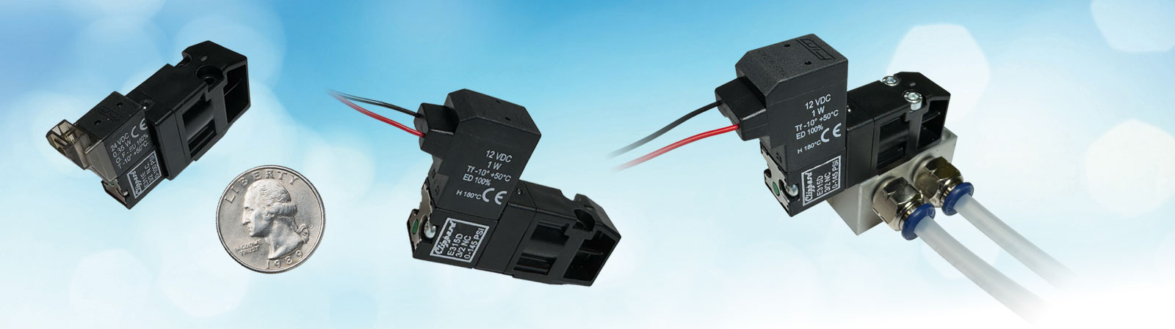

**CONTACT INFORMATION**

Rachel Desenberg

513.521.4261 x1243

[rachel.desenberg@clippard.com](mailto:rachel.desenberg@clippard.com)

**RELEVANT LINKS**

* [Product Landing Page](https://clippard.com/link/phv)
* [Technical Data Sheet](https://www.clippard.com/downloads/PDF_Documents/Product%20Data%20Sheets/Clippard%20PHV%20Series%20High%20Flow%20Booster%20Valve.pdf)
* [Product Overview Video](https://youtu.be/aIbJbhiCHMc?feature=shared)
* [Product Images](https://www.clippard.com/downloads/PR/PHV/Images)
* [Full Media Kit](https://www.clippard.com/downloads/PR/PHV)
* [Clippard Press Room](https://clippard.com/link/pr)

**PRESS RELEASE**

**Clippard Launches PHV Series Booster Valve**

*Compact Power for High-Flow Applications*

CINCINNATI, OH—August 27, 2025—Clippard, a leading manufacturer of miniature precision pressure and flow control solutions, announces the release of its new **PHV Series Booster Valve**, delivering exceptional high-flow performance in a compact, pressure-piloted design. Engineered for manifold mounting, the PHV Series achieves output flows up to **400 l/min at 100 psig** with a lightning-fast **10 ms nominal response time**, making it ideal for high-speed automation, large-volume dosing, quick-venting, and other demanding applications.

The PHV Series stands out with its **low power consumption**, featuring efficient coil designs that minimize energy draw—an advantage for battery-powered or thermally sensitive systems. Its **compact footprint** simplifies integration into dense assemblies and multi-valve manifolds, reducing installation time while saving valuable space. Available in **two pilot sizes** (10 mm and 15 mm), engineers can optimize performance for their specific application requirements.

Key features include:

* **High flow capacity** in a small package for rapid actuation and short cycle times
* **Low power draw** for energy-conscious designs
* **Compact manifold-mount design** for space-saving integration
* **Fast 10 ms nominal response** for precision control
* **3-way, normally-closed configuration** for built-in safety and versatility

The PHV Series is engineered for a broad range of industries, including **medical devices, analytical instrumentation, packaging, and industrial automation.** In applications such as vacuum generation, gas delivery, dosing systems, and rapid venting, the PHV provides unmatched reliability and speed without sacrificing efficiency.

For more information about the PHV Series Booster Valve, visit [clippard.com/link/phv](https://clippard.com/link/phv) or call 877-245-6247.

**ABOUT CLIPPARD**

Clippard is a third-generation, family-owned manufacturer specializing in precision pressure control, high-resolution flow control, and ultra-low leak solutions. Serving analytical instrumentation, medical device, and miniature process equipment markets, Clippard is trusted worldwide for accuracy, reliability, and performance. From innovative Spider Technology valves to advanced electronic controls and custom-engineered assemblies, Clippard partners with OEMs and design engineers to develop solutions that overcome complex challenges, optimize system performance, and support critical applications.

For more information, please visit [clippard.com](https://www.clippard.com/) or call 877.245.6247.

# # #

Clippard • 7390 Colerain Avenue, Cincinnati, OH 4539 • 513.521.4261

**SOCIAL MEDIA TOOLKIT**

**Clippard PHV Series Booster Valve**

**Product Overview**

Clippard’s PHV Series Booster Valve delivers high performance in a compact, pressure-piloted design. Engineered for manifold mounting, it drives output flows up to 400 l/min at 100 psig with a fast 10 ms nominal response. Its low power consumption ensures efficient, cool-running operation—ideal for dense assemblies and space-constrained environments. The PHV integrates seamlessly into control systems across medical, packaging, and industrial automation applications, offering reliable actuation and high flow without compromising energy efficiency or speed.

**Key Features**

* Max flow: 400 l/min @ 100 psig
* Fast actuation: 10 ms nominal response
* Low power draw: Efficient pilot-driven actuation for cooler, longer-lasting systems
* Compact footprint: Space-saving manifold mounting
* Flexible options: 10 mm or 15 mm pilot sizes for footprint vs. max. pressure balance
* Durable construction: Nickel-plated brass, stainless steel, nylon body with high-quality seals

**Applications**

* Vacuum generation and venturi control
* Blow-off and purge operations
* Pressure switching and quick-vent systems
* Packaging machinery and test stands
* Fluidic routing and pneumatic control systems

**Suggested Hashtags**

#Clippard #PrecisionControl #FlowControl

**Social Media Accounts**

[LinkedIn](https://www.linkedin.com/company/clippard-instrument-laboratory-inc-): @clippard

[X](https://x.com/CILCOM) (Twitter): @cilcom

[YouTube](https://www.youtube.com/@ClippardInstrumentLaboratory): @clippardinstrumentlaboratory

[Facebook](https://www.facebook.com/Clippard.Instrument.Laboratory/): @clippardinstrumentlaboratory

**EXAMPLE SOCIAL MEDIA POSTS**

Fast, efficient, reliable. When cycle time matters, Clippard’s high flow PHV Series Booster Valve delivers:

* 10 ms response for rapid actuation
* 400 l/min max. flow @ 100 psig
* Low power draw
* Compact, manifold-mount design
* Durable nickel-plated brass, stainless steel, and nylon construction

Ready to learn more? <https://clippard.com/link/phv>

Clippard’s PHV Series Booster Valve packs   
big performance into a small footprint. 10 ms response, 400 l/min max. flow @ 100 psig,   
low power.   
<https://clippard.com/link/phv>

With 400 l/min max. flow and 10 ms response, Clippard’s PHV Series keeps your systems moving—fast! This compact booster valve delivers high-speed control for a wide range of uses, including:

* Vacuum generation and venturi control
* Packaging machinery
* Blow-off and purge operations
* Test stands and quick-vent systems
* Fluidic routing in automation lines

Ready to learn more? <https://clippard.com/link/phv>

Clippard’s PHV Booster Valve delivers 400 l/min max. flow and 10 ms response in a compact, robust design. Perfect for vacuum generation, packaging, purge ops, and more.   
<https://clippard.com/link/phv>

Looking for more performance in less space? Clippard’s PHV Series Booster Valve delivers:

* 10 ms response keeps lines running fast
* 400 l/min max. flow boosts throughput
* Low power for energy savings and long life
* Compact, manifold-mount design for easy integration

Ready to learn more? <https://clippard.com/link/phv>

Looking for more performance in less space? Clippard’s PHV Booster Valve delivers 10 ms response, 400 l/min max. flow @ 100 psig, low power for energy savings, and a compact manifold-mount design for easy integration.   
<https://clippard.com/link/phv>

# # #

Clippard • 7390 Colerain Avenue, Cincinnati, OH 4539 • 513.521.4261